Name:____________________________________ PLTW: APP Creator
Date:_____________________________________ Lab 1.7 Game Time!
LT: I can create and store data during the execution of a program.
DIN: Login on to the computer- get on the PLTW website and open MIT App creator. If you are looking for guidance go on to my website and follow the tutorial
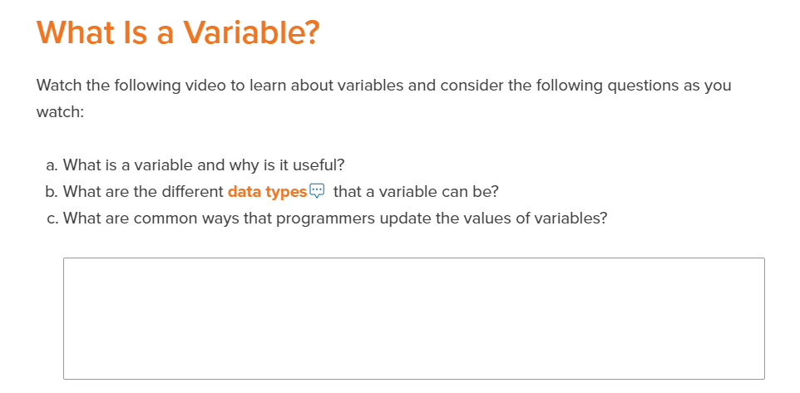
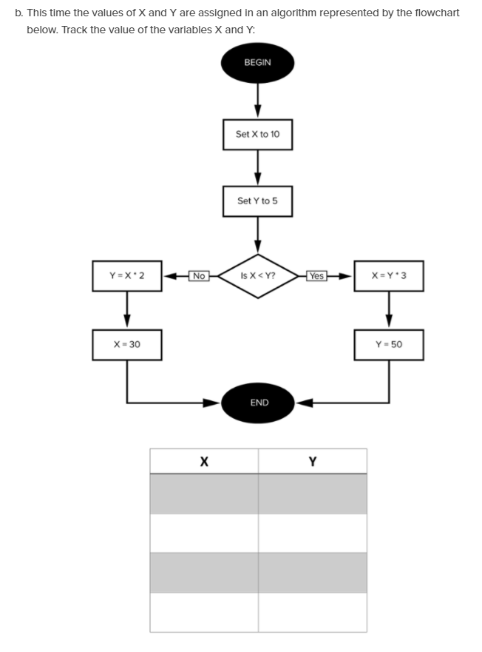
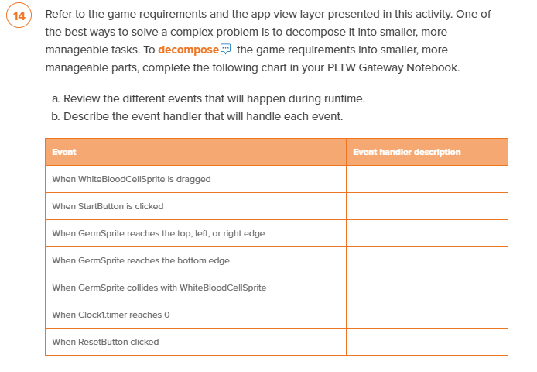

Ticket out the door Questions:

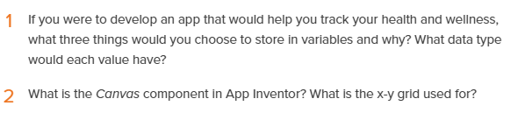

Show the teacher your app functioning correctly. _________________ (Teacher Signature)

