Name:____________________________________ PLTW: APP Creator
Date:_____________________________________ Lesson 1: Drag and Drop coding Introduction
LT: I can Identify elements of drag and drop coding and explain the function for each component.
DIN: Login on to the computer- get on the PLTW website and open MIT App creator. If you are looking for guidance go on to my website and follow the tutorial
As you complete the task, answer the following questions only:
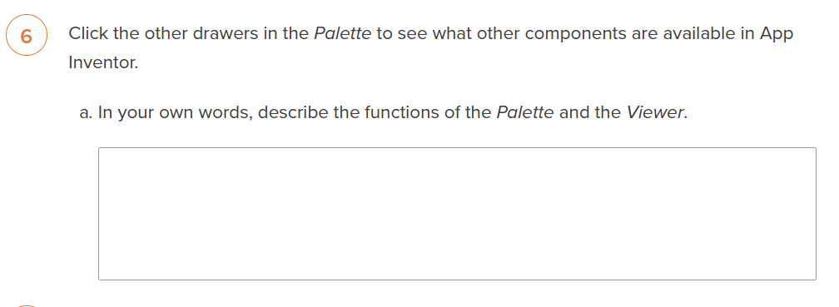
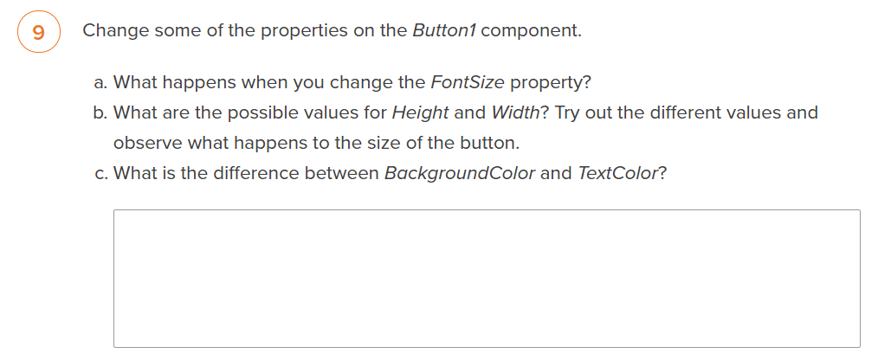
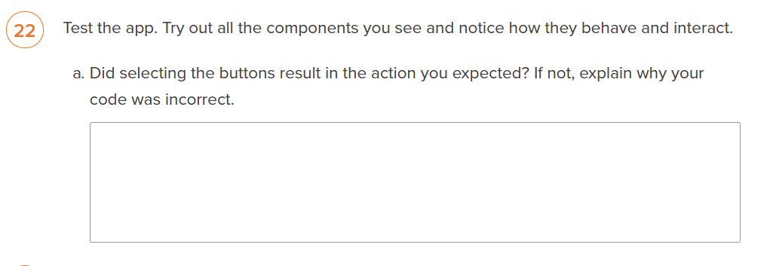
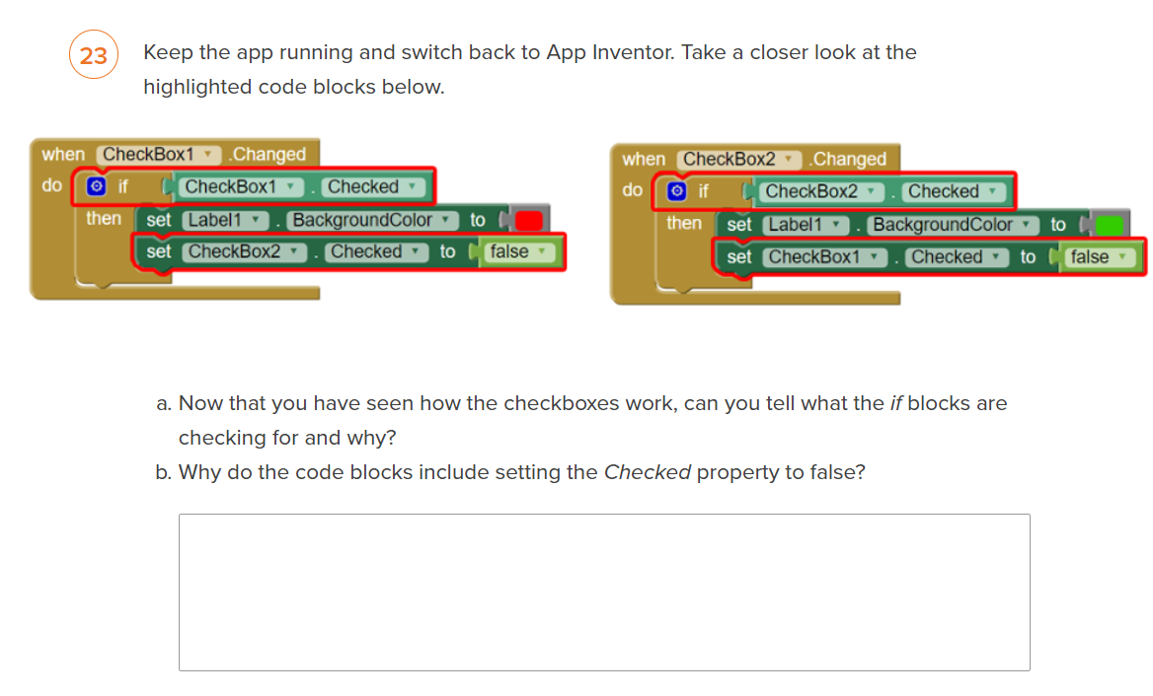
Ticket out the Door:
Show the teacher your downloaded APP: ____________ (Teacher Signature)

