Name:____________________________________ PLTW: APP Creator
Date:_____________________________________ Lesson 3: Events and Abstractions
LT: I can apply user-centered design principles when creating a solution.
DIN: Login on to the computer- get on the PLTW website and open MIT App creator. If you are looking for guidance go on to my website and follow the tutorial
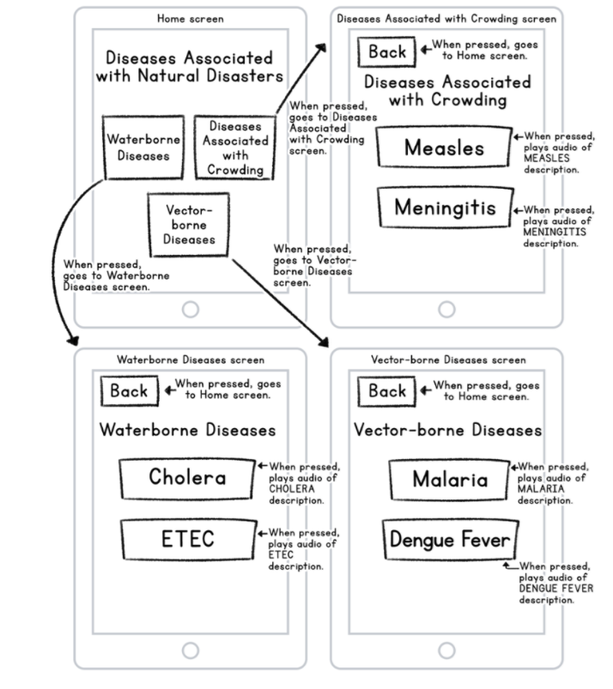
What is an event? _____________________________________________________________________
____________________________________________________________________________________
What is an Abstraction: _________________________________________________________________
_____________________________________________________________________________________

When you complete the disease Tracker code have it signed off by the teacher:___________________

Ticket out the Door:
