Name:____________________________________ PLTW: APP Creator
Date:_____________________________________ Lesson 5: Decision Time
LT: I can create programs by developing and testing code in a modular, incremental approach.
DIN: Login on to the computer- get on the PLTW website and open MIT App creator. If you are looking for guidance go on to my website and follow the tutorial
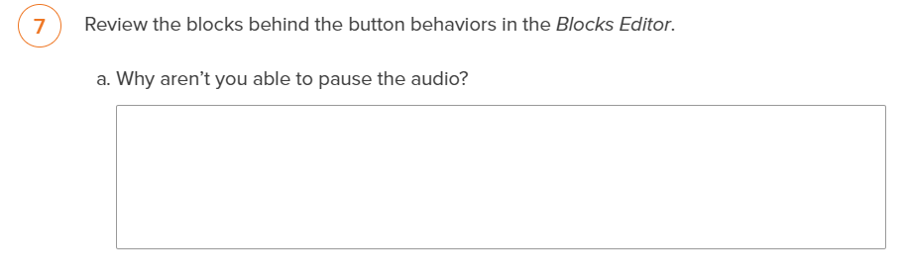
Ticket out the Door:
