Name:__________________________ PLTW APP Creators Unit 1 Let’s Create an APP
Guiding Questions: In what ways does technology affect people’s lives?
How do computer scientists design and develop mobile apps that meet desired needs?
What does effective teamwork look like?
Guided Tracker
Learning Target |  | Beginning | Developing | Accomplished | Exemplary | Evidence to support your self-assessment
I can design solutions to real world problems using drag and drop coding. |  |  |  |  |  | Project 1.8 Build a Body
Supporting Learning Targets | I can Identify elements of drag and drop coding and explain the function for each component. |  |  |  |  | Lesson 1: Drag and Drop Coding introduction
 | I can apply user-centered design principles when creating a solution. |  | 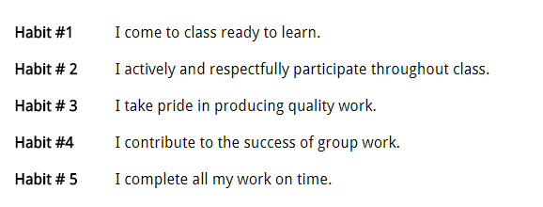 |  |  | Lesson 3: Events and Abstractions
 | I can create programs by developing and testing code in a modular, incremental approach. |  |  |  |  | Lesson 5: Decision Time
 | I can describe and analyze moments within a problem-solving process where persistence, iteration, and the positive aspect of failure played an important role in gaining understanding about a problem or unexpected observation. |  |  |  |  | Lesson 6: Bug Blaster
 | I can create and store data during the execution of a program. |  |  |  |  | Lab 1.7 Game Time!

